Ohio Leadership Institute
Ohio Model United Nations
2019-2020 Calendar

May 3, 2019 OMUN ADVISOR’S TRAINING & INFORMATIONAL WORKSHOP
Hyatt Regency Columbus

May 5, 2019 Youth Advisory Board Meeting
Hyatt Regency Columbus

June 2-4, 2019 OHIO LEADERSHIP TRAINING CONFERENCE
Hyatt Regency Columbus
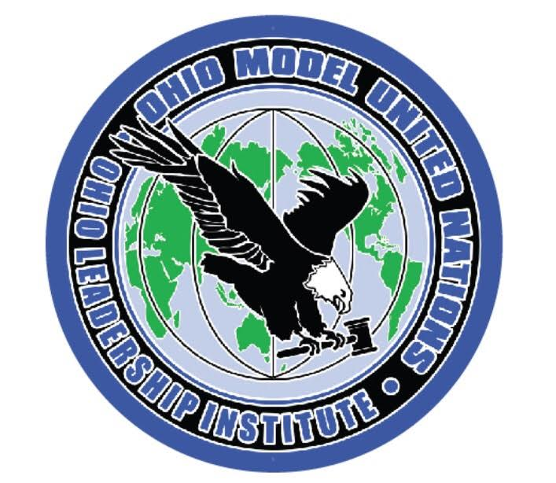
September 8, 2019 Youth Advisory Board Meeting
Hyatt Regency Columbus

October 25, 2019 SR OMUN REGISTRATION & DEPOSITS DUE
$100 deposit for each student or adult attending
        - Official School Registration Forms DUE
        - Hotel & Lodging Forms DUE
        - Delegation Forms DUE

November 1, 2019 SR OMUN RESOLUTIONS DUE
Must be submitted by email as MS Word Documents.
Last day to cancel an individual registration for SR OMUN

November 3, 2019 State SR OMUN OFFICER’S MEETING
Hyatt Regency Columbus

December 1, 2019 SR OMUN FINAL FORMS DUE
        - Talent Showcase Forms
        - Officer Candidate Forms

December 8-10, 2019 SR OHIO MODEL UNITED NATIONS
Hyatt Regency Columbus

February 2, 2020 State JR OMUN OFFICER’S MEETING
Hyatt Regency Columbus

February 7, 2020 JR OMUN REGISTRATION & DEPOSITS DUE
$100 deposit for each student or adult attending
        - Official School Registration Forms DUE
        - Hotel & Lodging Forms DUE
        - Delegation Forms DUE

February 14, 2020 JR OMUN RESOLUTIONS DUE
Must be submitted by email as MS Word Documents.
Last day to cancel an individual registration for JR OMUN

March 2, 2020 JR OMUN FINAL FORMS DUE
        - Talent Showcase Forms
        - Officer Candidate Forms

March 15-17, 2020 JR OHIO MODEL UNITED NATIONS
Hyatt Regency Columbus

May 1, 2020 OMUN ADVISOR’S TRAINING & INFORMATIONAL WORKSHOP
Hyatt Regency Columbus (tentative date)

June 7-9, 2020 OHIO LEADERSHIP TRAINING CONFERENCE
Hyatt Regency Columbus (tentative date)

