2021-2022
Ohio Model United Nations
Advisor’s Informational & Global Education Workshop

- Receive Ohio Model United Nations Updates, Materials & Information!
- Learn how to participate in the Ohio Model United Nations program!
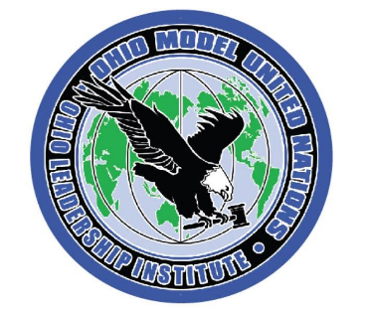
- Learn to use global education activities and resources in your classroom!
- Learn to implement 21st century skills activities in your classroom!

DATE: Friday - September 10, 2021
PLACE: Hyatt Regency Hotel, Columbus
TIME: 9:00AM – 3:00PM
COST: $90 (includes continental breakfast, lunch and materials)
Can bring check on day of workshop or mail in advance to the Institute.

REGISTER by E-Mail to ohioleader@gmail.com

Ohio Model United Nations
2021-2022 Advisor’s Informational & Global Education Workshop

Name ______________________________ School ____________________________

School Address __________________________City ______________ ZIP _________

School Phone ________________________ Home Phone ______________________

E-Mail Address _________________________________________________________
(workshop confirmation sent by e-mail)

E-MAIL TO: ohioleader@gmail.com or MAIL TO: Ohio Leadership Institute, 240 Woodland Avenue, Columbus OH 43203

QUESTIONS? E-Mail: ohioleader@gmail.com
Visit www.ohioleader.com for additional information. PHONE: 1-614-826-2830

