2024-2025 School Year
Ohio Leadership Institute’s
Ohio Model United Nations
2024-2025 Advisor & NEW School Workshop

- Receive Ohio Model United Nations Updates, Materials & Information!
- Learn how to participate in the Ohio Model United Nations program!
- Learn to use global education activities and resources in your classroom!
- Learn to implement 21st century skills activities in your classroom!
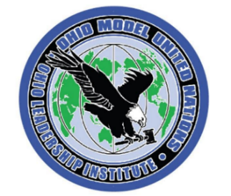

DATE: Friday – September 13, 2024
PLACE: Hyatt Regency Hotel, Columbus
TIME: 9:00AM – 3:00PM
COST: FREE (includes continental breakfast, lunch, and materials)
[Paid by grant from the Institute].

REGISTER by E-Mail to ohioleader@gmail.com

Ohio Model United Nations
2024-2025 Advisor & NEW School Workshop

Name ______________________________ School ____________________________

School Address __________________________City ______________ ZIP _________

School Phone ________________________ Home Phone ______________________

E-Mail Address _________________________________________________________
(workshop confirmation sent by e-mail)

E-MAIL TO: ohioleader@gmail.com or MAIL TO: Ohio Leadership Institute, 240 Woodland Avenue, Columbus OH 43203

QUESTIONS? E-Mail: ohioleader@gmail.com or visit www.ohioleader.com.

